**Project Development Phase**

**Model Performance Test**

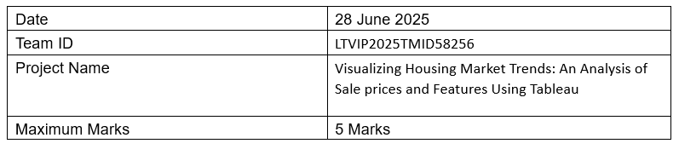

## Model Performance Testing:

The project team shall fill the following information in the model performance testing template.

|  |  |  |
| --- | --- | --- |
| S.No. | Parameter | Screenshot / Values |
| 1 | Data Rendered | Housing dataset from CSV, cleaned using Tableau Prep, visualized in Tableau Public |
| 2 | Data Preprocessing | Null values removed, categorical fields standardized, aggregated KPIs calculated |
| 3 | Utilization of Filters | Filters for Renovation Status, Year Built, Bathrooms, Bedrooms, Floors |
| 4 | Calculation Fields Used | Average Sale Price, Years Since Renovation, Age of House, Count of Records |
| 5 | Dashboard Design | KPIs (3), Histogram (1), Pie Chart (1), Grouped Bar Chart (1) → Total: 6 Visualizations |
| 6 | Story Design | Interactive story sequence with titles and dashboard explanations → Total: 6 Views |